Federalist action for the European Council meeting on 13-14 December 2012

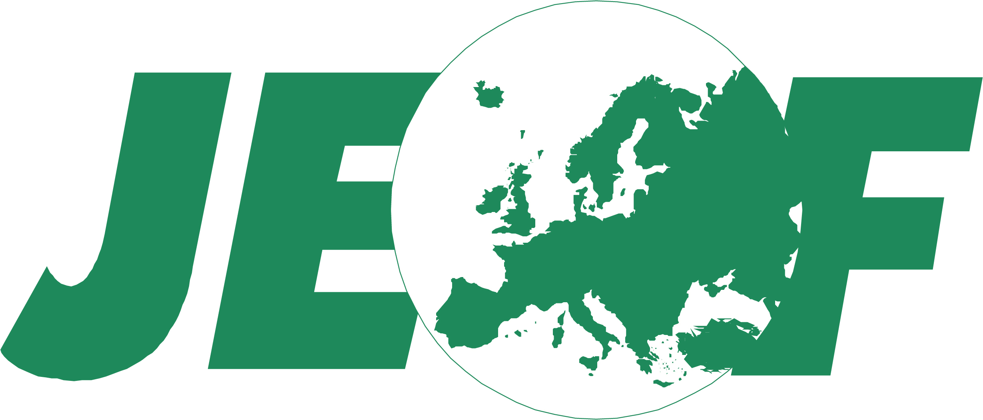

12.12.12: TIME TO DECIDE!

TIME FOR A EUROPEAN FEDERATION!

The meeting of the European Council in Brussels on 13-14 December 2012 will face difficult decisions on the launch of a banking union and a blueprint for a fiscal and political union to strengthen the Eurozone. After a few years of Euro-crisis and economic recession, countless meetings of the European Heads of State and Government, ineffective short-terms measures and promises of more comprehensive solutions in the future, it is time to decide, before growing social discontent and Euro-scepticisms will make it impossible to decide.

Time for partial solutions is over. A sustainable monetary union requires a banking union, a fiscal union and a democratic European government. A serious banking union requires not only supervision, but also the power and resources to act when supervision fails. A serious fiscal union requires not only stringent controls on national budgets, but also a robust power to tax and spend at European level to promote growth and support member states when in difficulty. A serious political union can’t mean more and more meetings of the heads of state and government, each of whom has a country to run: it requires a European government. And the power to control national budgets and to tax European citizens and corporations requires European democracy. It is time for a new constitutional pact that reshapes the Euro-zone and the other countries willing to join such a project into a democratic federation.

The federalists movements ask the European Council to make plans to convene a constituent Convention with the mandate to prepare a federal constitution that: (a) brings together plans for a banking, fiscal, economic and political union for the Euro-zone and the other countries willing to join such a project; (b) gives the Euro-zone effective and democratic governance and decision-making structures and adequate economic resources; (c) provides for differentiated stages of European integration, allowing forms of looser integration for those countries who don’t intend to join the Euro.

We ask the European Parliament to support such proposals and develop a plan for a federal constitution to be submitted to such constituent Convention.

UEF European Secretariat: Tel: +32 (0)2 508 30 30 I info@federalists.eu

JEF Europe Secretariat: Tel: +32 (0)2 512 00 53 I info@jef.eu

